Boy
Write 'boy' in Arabic, following the guide.

This is how you write boy in Arabic.

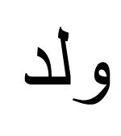
Try and write boy yourself following the dots.

boy

______________________________________________________

-----------------------------------------------------------------------------
______________________________________________________

