Cut and Glue Building

Many geometrical shapes were used in the building of mosques.

The shapes below could have been used in Islamic buildings.

On a separate piece of paper, trace and cut out as many of the shapes as you need to create a building. Once you are happy with the design, glue the pieces in place.

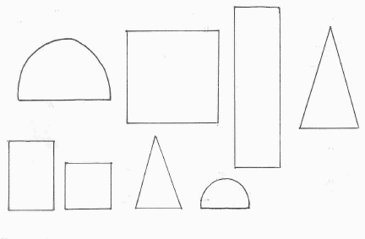

My design

