The Maze
Here is a special journey for you to take. Try and find your way through the maze.

Start
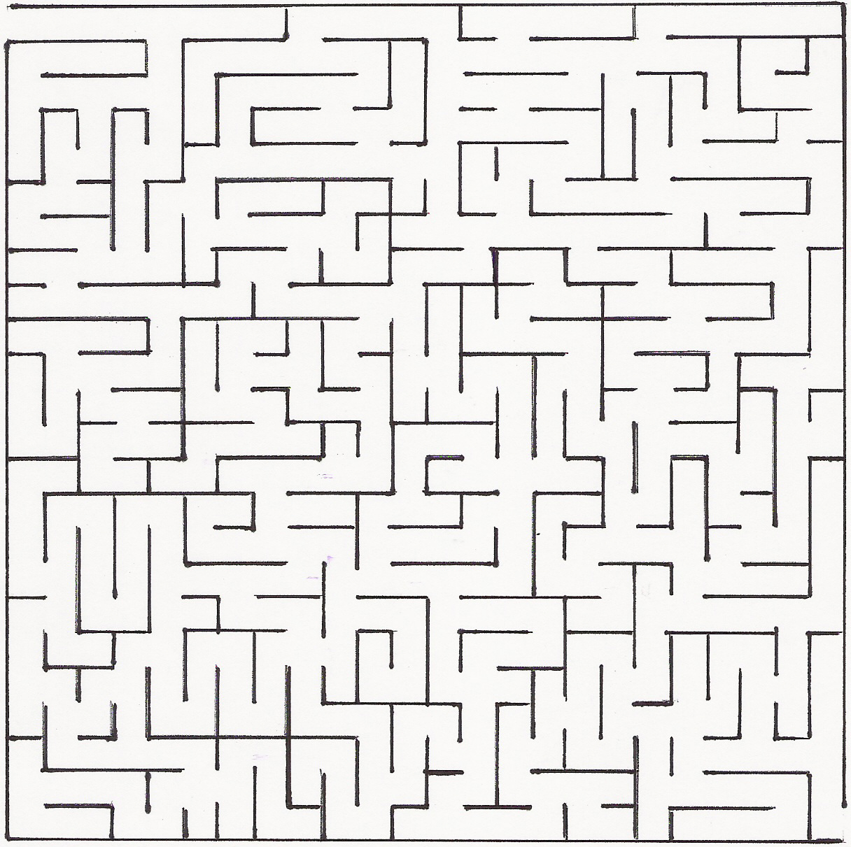Finish

