Write a Calligraphy Poem

Here is a poem written by Nizar Kabbani in English.
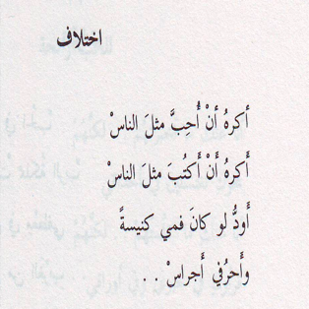
Difference
I hate to love like everyone else,
I hate to write like everyone else,
I wish my mouth were a church.
I wish my letters were bells.

Here is the same poem written in Arabic.

Try and write the poem in Arabic following the script. Remember to start on the right hand side of the page.

________________________________________________________

________________________________________________________

________________________________________________________

________________________________________________________

________________________________________________________

